Guide to Total Joint Replacement
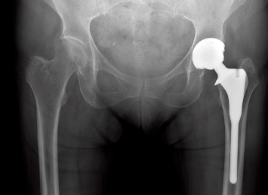
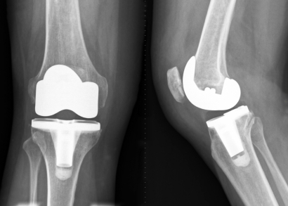

TABLE OF CONTENTS
1. INTRODUCTION
- THANK YOU FOR CHOOSING LUBBOCK HEART & SURGICAL HOSPITAL 4
2. OVERVIEW OF TOTAL HIP REPLACEMENT 5
3. OVERVIEW OF TOTAL KNEE REPLACEMENT 6
4. HOW TO PREPARE FOR YOUR UPCOMING SURGERY 7-9
- EXERCISE
- DIET AND NUTRITION
- SMOKING AND ALCOHOL USE
- DIABETIC GUIDELINESS
- MEDICATIONS
- GETTING YOUR HOME READY
5. WHAT TO EXPECT BEFORE SURGERY 10-12
- PRE-ADMITION ASSESSMENT AND TESTING
- INSURANCE AUTHORIZATION
- PLANNING AHEAD
- WHAT TO BRING TO THE HOSPITAL
- PRE-REGISTRATION
- INFECTION PREVENTION
- MY CHECK LIST
6. DAY OF SURGERY 12
- WHEN YOU ARRIVE
- PAIN CONTROL
- SURGERY
7. YOUR HOSPITAL STAY 13-14
- RECOVERY
- THERAPY
- PAIN CONTROL
8. DISCHARGE AND TRANSITION HOME 15-16
9. PRE OPERATIVE TOTAL HIP/KNEE REPLACEMENT EXERCISE PROGRAM 16-18
10. WHEN TO CALL FOR HELP 19
11. HOME SAFETY AND COMMON WAYS TO PREVENT FALLS 20
 | Lubbock Heart Hospital is a physician-owned hospital and conducts its operations under the names of
 | Lubbock Heart & Surgical Hospital and NorthStar Surgical Center, the latter being an off-campus, hospital outpatient department.
 | Below is a list of the Hospital's owners or investors who are physicians or immediate family members of physicians
 | PHYSICIAN OWNERSHIP
 | PHYSICIAN INVESTOR | SPECIALTY | PHYSICIAN INVESTOR |  | SPECIALTY
 | Addington, Charles | Family Medicine | Rizzo, Joseph A. |  | Cardiology
 | Barinque, Mark | Podiatry | Robertson, Donald J. |  | Cardiology/Cardio Thoracic Surgery
 | Beck, Howard | Urology | Schaub, Lowry |  | Anesthesia
 | Borno, Mounir Y. | Cardiology | Scioli, Mark William |  | Orthopedic Surgery
 | Britton, Jr., Carl Lee | Urology | Scovell, III, John Field |  | Orthopedic Surgery
 | Carr, Robert | Orthopedics | Sharif, M. Alan |  | Cardiology
 | Davis, William Jewell | Anesthesia/Pain | Shephard, II, David Michael |  | Orthopedics
 | Grattan, James G. | Cardiology | Shronk, Kenneth |  | Anesthesia
 | Haggard, Derick | General Surgery | Smitherman, Tony Bryan |  | Orthopedics
 | Hallier, Stephen | Anesthesia/Pain | Snodgrass, P.C. |  | Gastro Intestinal
 | Hancock, Joseph | Gastro Intestinal | Spore, Scott |  | Urology
 | Headrick, Jeff Dodson | Orthopedics | Solis, Roberto E. |  | Cardiology
 | Hnatek, Joe D. | Anesthesia | Stephenson, Kenneth Alan |  | Orthopedics
 | Hobgood, Brooke | Anesthesia | Vallabhan, Girish |  | Urology
 | Mahal, Kanwaljit "Sonny" | Urology | Wilson, Joseph Nathan |  | Orthopedics
 | McClain, Chase | Anesthesia | Wilson, Selma |  | Pain Management
 | McNeely, Jeffrey | Podiatry
 | Nguyen, Adam | Podiatry
 | Patel, Nayankumar A. | Nephrology
 | Pollock, Garry Robert | Orthopedics
 | Ramsey, Jason | Orthopedics

THANK YOU FOR CHOOSING LUBBOCK HEART & SURGICAL HOSPITAL

Thank you for choosing Lubbock Heart & Surgical Hospital for your total joint replacement. Our number one priority at Lubbock Heart & Surgical Hospital is to provide safe quality care to our patients. With that in mind, we have created this guide to help ensure that your experience with us from admission to discharge is as rewarding and pleasant as possible.
Our Total Joint Pre-Operative Educational program and information guide has been designed to provide you and your family with the important information that you will need to achieve the best outcomes from your joint replacement surgery. Patients having joint replacement surgery are highly encouraged to attend along with individuals who will be assisting you through your surgical preparations and recovery. Please bring this Total Joint Replacement Guide with you. During this class you will receive useful information about your surgery and recovery. You will also have the opportunity to ask questions. This guide covers the following:
- Overview of Total Hip Replacement

- Overview of Total Knee Replacement

- How to prepare for your upcoming surgery

- What to expect before, day of surgery, and during your hospital stay

- What to expect and what to do to continue your successful recovery at home
Lubbock Heart & Surgical Hospital offers a unique approach in treating patients who undergo joint replacement surgery with a complete team approach. The team includes your surgeon, and multi-disciplinary heath care team, and YOU. By participating in this program we hope to help you have:
- Decreased anxiety about upcoming surgery

- Increased knowledge of condition and what to expect

- Shorter hospital stay, shorter recovery time, and faster return to daily activities

- Lower infection rate

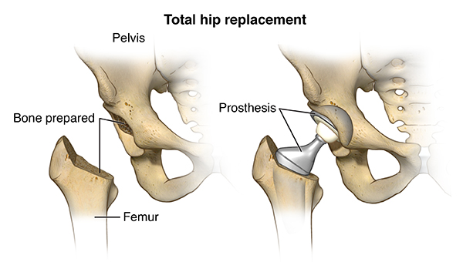

The hip joint helps us keep out balance and supports our weight with all of our activities and movements. The upper end of the leg bone (femur) has a rounded head (femoral head) that fits into a socket (acetabulum) to form the hip joint.

During total hip replacement surgery, the damaged part of the hip is removed and replaced with implants. Your surgeon will select the implants that are best for you based on your activity level, age, and body type.

While recovering from your total hip replacement, you will have specific precautions provided to you by your surgeon and therapist. These precautions are very important to follow in order to prevent hip dislocation and to allow for a full recovery. Your surgeon will let you know when it is safe to stop following these precautions.

- DO NOT BEND YOUR SURGICAL HIP BEYOND A 90 DEGREE ANGLE
- DO NOT CROSS YOUR LEGS
- DO NOT PIVOT OR TWIST ON YOUR OPERATIVE LEG
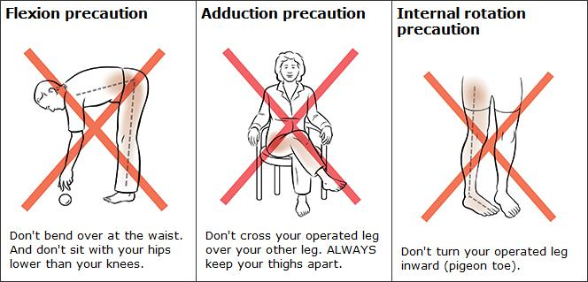

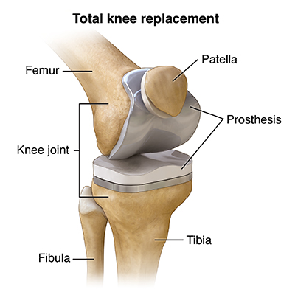
The knee joint is the largest joint in the body. The knee is located at the meeting point of the thigh bone (femur) and shin bone (tibia). It’s the joint that allows the leg to bend and straighten.

During total knee replacement surgery, the damaged part of your knee is replaced with an implant. There are many types of implants made of different types of materials. Your surgeon will determine the type of implant that is best for you based on your activity level, age, body type, and the amount of bone and bone tissue that is available.

Depending on your surgeon, a CPM (Continuous Passive Movement) machine may be used after surgery to allow gentle passive knee flexion and extension of your new replacement. During your hospital stay your therapist along with nursing will provide education about your specific surgeon’s protocol.
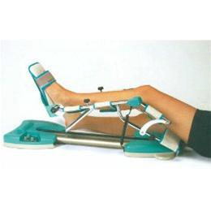
PREPARING FOR SURGERY
EXERCISE
- Talk with your surgeon/family physician about exercise prior to surgery, discuss any medical issues that may prevent you from being more active. The stronger you are prior to surgery will help lead to a successful outcome and recovery.
- Exercise helps improve your strength, range of motion, and endurance
- If exercise is too painful at this time, view and become familiar with the exercises provided in this program
- Upper body conditioning exercises help reduce muscle soreness and fatigued caused by the use of a walker or other walking aides
- Walking or water exercise programs increase endurance, flexibility and overall strength
- If you are already exercising, excellent, keep it up!
DIET AND NUTRITION
- Consult with your physician about any diet recommendations he/she might have based on your individual needs
- Healthy eating and proper nutrition before your surgery aids in the healing process
- Stay hydrated
- Be aware of your own medical conditions which may limit certain food types and fluid consumption. Examples: Diabetic restriction, Cardiac conditions, Blood pressure issues
- Eat foods higher in fiber to help avoid constipation often caused by pain medications. The combination of anesthesia and your pain medication may slow down your bowel function after surgery
SMOKING AND ALCOHOL USE
- Smoking increases the risk of medical complications, slows the recovery process, causes breathing problem, and can also increase the risk of infection and blood clots after surgery. We encourage you to quit at least a few weeks prior to surgery
- Tell your physician if you consume alcohol and be honest about the amount. Potential withdrawal and other alcohol-related problems may affect your recovery

DIABETIC GUIDELINES
- Managing your blood glucose (sugar) levels is always important
- Manage your diet if you have precautions
- Surgery can affect your normal diet and may change your normal medication schedule
- Managing your blood glucose levels before and after surgery can help reduce the risk of problems after surgery such as infection and other complications
- Make sure you physician is aware of your medical conditions
MEDICATIONS
- Communicate all medications you are taking with your surgeon
- Some medications thin your blood, increase the risk of bleeding after surgery, or interfere with the healing process (Advil, Motrin, Aleve, Coumadin are just a few).
- Make a list of all medication that you are taking including over the counter and herbal supplements and provide your surgeon and medical team a copy
- Contact your surgeon’s office for any question regarding your medication and make sure that you are aware of when to stop taking certain medication prior to surgery
GETTING YOUR HOME READY
- Think ahead, prepare small meals and freeze them
- Remove throw rugs and clutter
- Make a clear path to your bathroom
- Make sure you are able to get around furniture with your walker or walking aid
- Make sure you have a place to sit that is not too low
- Make arrangements for pets if they are a hazard
- Ask for help from family or friends for house care and chores
- Make sure you have easy access to a phone at all times and place frequently used items in reach
- Obtain DME (Durable Medical Equipment), walker, bedside commode, or shower chair prior to surgery (your physician/surgeon can provide you with a medical order prior to surgery for some items)
- Hip replacement patients will benefit from: bed side commode with arms, Front wheel walker, shower chair/shower bench, long handled reacher (grabber, sock aide, long handle shoe horn, and long handle sponge. During your stay education will be provided on the use of these items
- Knee replacement patients will benefit from: Front wheeled walker, bed side commode, shower chair/shower bench
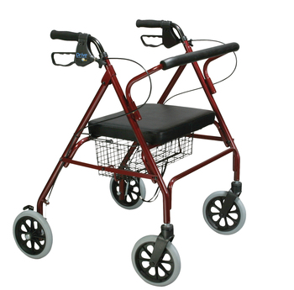
FRONT WHEELED ROLLING WALKER: YES 4 WHEELED ROLLING WALKER: NO

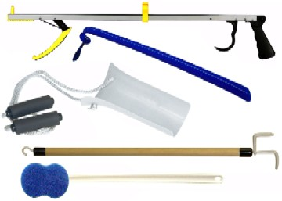
HIP KIT: LONG HANDLE REACHER, LONGE HANDLE SHOE HORN, SOCK AIDE, DRESSING STICK, AND LONG HANDLE SPONGE.

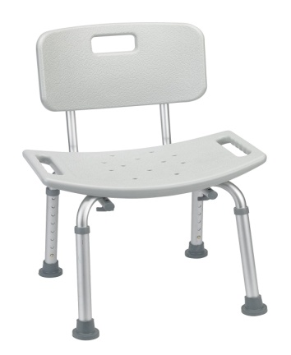 SHOWER CHAIR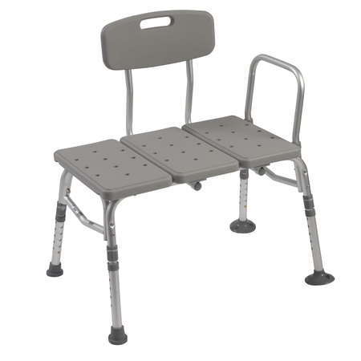TUB TRANSFER BENCH

BEFORE SURGERY
PRE-ADMISSION ASSESSMENT AND TESTING
- Your surgeon will set you up for a pre-operative work-up. This is to assess your overall health and readiness for surgery. You will go over all past medical/surgical history, medications, and any other medical issues
- At pre-operative work-up blood work, x-rays, EKG/stress test, or other additional testing may be performed
INSURANCE PRE-AUTHORIZATION
- Contact your insurance company prior to surgery, some insurance requires preauthorization. Ask what is covered under your plan
- Front wheeled walker, bedside commode, and shower chair
- What is covered after your leave the hospital? Therapy services, Home Health Services, Skilled Nursing care
PLANNING AHEAD
- If you live alone ask family or friends to stay with you during your recovery for the first week or longer if possible
- Schedule any necessary appointments such as outpatient therapy to ensure there is not a delay in your post-operative recovery
- Have a driver ready for you at discharge and to therapy sessions. You will not be able to drive until released by your surgeon
WHAT TO BRING TO THE HOSPTIAL
- Current list of all your medications and supplement, noting which ones have been stopped. You can also bring all medications with you, especially if you have new ones that have been recently started
- CPAP machine
- Personal items: glasses, hearing aids, personal toiletries
- Cell phone and charger
- Driver’s license, insurance card, Medicare card
- Loose fitting clothes, shoes with enclosed back , no flip-flops/sandals
- Bring walker and hip kit, but leave it in your vehicle. Your family/friend can bring this in once you are in your assigned room after surgery

PREREGISTRATION
- You will have to come to the hospital to preregister, any further lab work or diagnostic testing needed by your surgeon you will be notified at this time
- You will be notified of what time to be at the hospital on the day of your surgery
- SIGN UP FOR YOUR PRE-OPERATIVE TOTAL JOINT EDUCATION CLASS. This class is highly recommended by your surgeon
INFECTION PREVENTION
- HIBICLENS will be given to you at the Total Joint Education class or at your pre-registration appointment
- Use HIBICLENS to shower 2 days before surgery and the morning of surgery
(3 showers = 2 nights before surgery, 1 night before surgery and morning of surgery)
- Do NOT use on face or genitals
- Dispense 5ml of HIBICLENS into wet cupped hands
- Rub vigorously for 15 seconds from head to toe scrubbing entire body (NOT on face or genitals)
- Rinse and dry thoroughly
- Put clean sheets on bed the day before surgery for after your 2nd shower, also wear clean pajamas.
- NO shaving any part of the body for 2 days before surgery, any hair that needs clipped/shaved the nurses will take care of the day of surgery
- Do NOT apply any lotion, powders, creams, perfume, cologne, makeup or contact lenses the day of surgery.
- Deodorant and mouth care is acceptable
- Remove all nail polish

CHECKLIST TO COMPLETE PRIOR TO SURGERY:
- I have completed pre-operative work-up
- I have completed pre-admission testing and pre-registration
- I have reviewed medications with doctor
- I know the dates to stop certain medications
- I have attended pre-operative joint replacement education class
- I have updated my dental work
- I have stayed active and have been performing strengthening exercises provided in this Guide
- I have my home in order
- I have a front wheeled walker, bedside commode, shower chair/tub bench
- I have a caregiver that will be with me at hospital and at home to assist with my needs as I recover
- I have arranged for a driver to drive me to my follow-up appointments
- I have HIBICLENS
DAY OF SURGERY
BEFORE ARRIVAL
- Take medications that your surgeon/physician has informed you to
- DO NOT eat or drink anything past the time you were instructed. No gum or candy is allowed
- Follow all other recommendations given by you surgeon
WHEN YOU ARRIVE
- Your operative site will prepped and your surgeon will review the procedure and answer any questions
- Anesthesiologist will talk with you about types of anesthesia that will be used during your surgery and answer any questions
SURGERY
- Surgery time (typically 1-3 hours) will vary from patient to patient depending on replacement needed and surgeon.
- After surgery you will recover in Post Anesthesia Unit (PACU)
- The surgeon or representative will speak with your family while you are in recovery

HOSPITAL STAY
- After recovery in PACU, you will be moved to your assigned room. Your family/friends will you meet you there
- Your Nurse will do the following:
  - Check vital signs frequently
  - Check your incision
  - Start IV fluids, antibiotics and pain medications
  - Check compression devices and stockings.
- Once you are awake and your nurse feels you are ready, you will be started on a liquid diet. If the liquids are tolerated you will progress to solid food. Please let your Nurse, Dietitian, and Nutrition staff know about your preferences and restrictions
- A physical and/or occupational therapist will come in to check on you. If you are ready, they will help you to get out of bed and walk for the first time. At this time they will begin education about your recovery and go over all precautions that pertain to you.
- Remember: Do not get out of bed without assistance. Movement is vital to your recovery to prevent complications such as blood clots and pneumonia, but it must be done so in a safe manner
- The morning after surgery staff will assist you out of bed and help you get dressed in loose fitting clothing that you brought from home. You will have breakfast and take medications. Your physical/occupational therapist will come in and you will be taken to “Joint Camp”. If your surgeon has requested that you not attend “Joint Camp”, you will be seen by a therapist one on one. At “Joint Camp” you will begin strengthening and range of motion exercises, as well as receive education that is important for your recovery. Your family is encouraged to attend with you so that they can hear the education provided and see the exercises you are performing. After lunch you will again attend “Joint Camp”. If your surgeon orders the use of a CPM machine, it will be placed on after your afternoon “Joint Camp” session. You will be educated on your specific physician’s protocol and on proper use of this machine.
- Each day after this will follow the same therapy schedule and your activity levels will be increased. Your therapist will provide education and training about stairs, getting in and out of bed safely, and car transfers. Make sure you communicate with your surgeon if you have any concerns about discharge

PAIN CONTROL
- ONE OF THE SINGLE MOST IMPORTANT PARTS OF YOUR CARE IS CONTROLLING YOUR POST-OPERATIVE PAIN
- Your pain medication will be started after surgery in recovery
- YOU, your physician and your nurses will create an individualized plan of care to meet your specific pain control needs. YOU HAVE TO BE PROACTIVE IN YOUR CARE
- Pain medication can be administered orally (by mouth), intramuscular (injections), or intravenously (through your IV)
- Take your medication on a regular basis. Do not wait until your pain is severe to ask for medication or it will be very difficult to bring your pain levels down to a comfortable level. Set an alarm for reminders to call for pain medication
- Have realistic expectations. Your pain level will not be at “0” as you just underwent major surgery. If we can keep your pain below 5/10 then you will be able to recover faster, move better, and attend therapy
- Some medication will be scheduled for you, others YOU will have to ask for. These are called PRN, which stands for “as needed”. Each surgeon has a different protocol. Your treating nurse can provide you education and instructions on what is best to take and when. A white board can be used in your room along with a laminated medication schedule to keep track
- You will be asked to describe your pain many times a day using a numerical scale as seen below
- Communicate with your physician and nurse if you experience any adverse reaction or side effects to your medication (Nausea, Vomiting, Itching, Rash, Hallucinations, general “ill” feeling, difficulty breathing)
- Depending on your surgeon ICE therapy may be used to help control pain
- BE ACTIVE IN YOUR PAIN CONTROL, YOU HAVE TO COMMUNICATE

DISCHARGE AND TRANSITION HOME
- Discharge planning starts the moment you decide to have surgery. You will need to arrange a ride home for the day of discharge; most patients are ready for discharge 1-3 days after surgery, however specific criteria must be met. You will be able to discharge from the hospital when:
- You are medically stable
- Your surgeon has approved discharge
- You are able to eat and have good bowel and bladder function
- Your pain is controlled with your oral medication
- You have met your Physical and Occupational Therapy goals
- Nursing will provide you with discharge instructions for cleaning and maintaining your incision site, how to change your bandage, and instructions about medications. At this time you will be given orders for pain medication and anti-coagulant (blood thinning) medication to lessen the chance of harmful clots forming, outpatient therapy script (make appointment as soon as possible after discharge from hospital) and precautions to be aware of with your new joint.
- If you have not met the criteria to be discharged home. Skilled Nursing Home, Swing bed, or Acute Rehab placement may be needed. Arrangements will be made with our Case Management Team
HOME
- In general, patients do well after discharge. However, it’s important that you contact the Clinical Orthopedic Liaison and/or Surgeons office if the following occur:
- You have increased pain in the operative site
- There is new or increased redness or warmth since discharge
- The operative site is increasingly swollen
- Your calf becomes swollen, tender, warm, or reddened
- If you have a temperature equal or greater than 101.5 degrees
- Odor from incision sight
- If you have a fall
- If yellow/green cloudy drainage from the incision site, or increased drainage in general
- If you are unable to have a bowel movement
- Knee patients: if your ability to flex (bend your knee) has decreased or remains the same as when you were discharged from the hospital

- CALL 911 IF CHEST PAIN/TIGHTNESS AND SHORTNESS OF BREATH OCCUR
- Request Lubbock Heart and Surgical Hospital if you live in Lubbock, we are familiar with your care
- Remember, pain is expected during your recovery. Maintain pain medication schedule as directed by your surgeon
- Get up and move, movement will decrease stiffness and pain as well as improve your independence
- You will have swelling and bruising to the involved extremity
- Continue with your rehab and exercises
- ICE can be used as directed by your therapist and surgeons protocol along with elevation for swelling
- Do not sit for longer than 30-40 minutes, continue to perform your exercise program, Keep moving
- Remember to take short frequent rests during the day, you are healing
- Eat well balanced meals and stay hydrated
- Wash hands frequently
- Follow your surgeons instructions
- Most people experience a significant reduction in joint pain and improvement in their overall quality of life following joint replacement surgery. While you feel better, remember to not overwork your new joint and allow for adequate time to heal. The healing process can take up to 12 months.

Exercises

Ankle Pump

Slowly push your foot up and down.

Repeat this exercise 10-15 times, 3-4 times per day
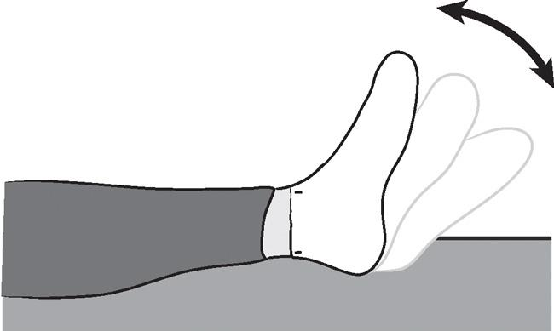

Bed-Supported Knee Bends

Slide your foot toward your buttocks, bending your knee and keeping your heel on the bed. Do not let your knee roll inward.

Repeat 10-15 times, 3-4 times per day

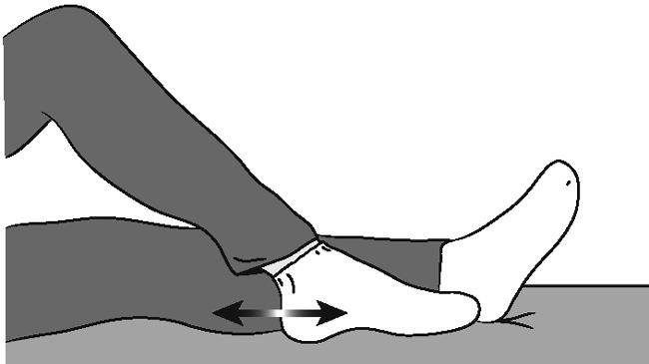

Buttock Contractions
Tighten your buttock muscles and hold to a count of 5.
Repeat 10-15 times. Repeat for 3 or 4 sessions a day.
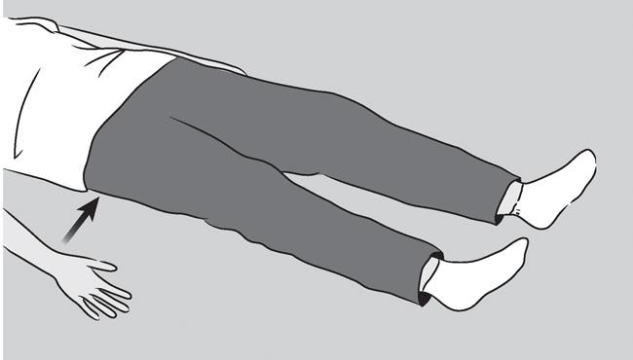

Abduction Exercise
Slide your leg out to the side as far as you can and then back.
Repeat 10-15 times. Repeat for 3 or 4 sessions a day
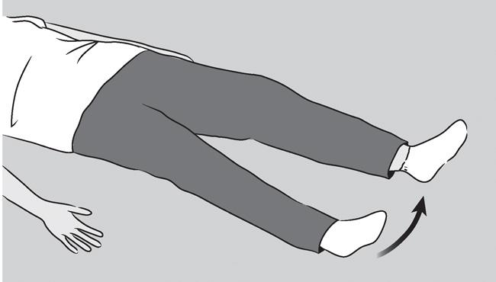

Quadriceps Set
Tighten your thigh muscle, try to straighten your knee. Hold for 5-10 seconds.
Repeat 10-15 times.
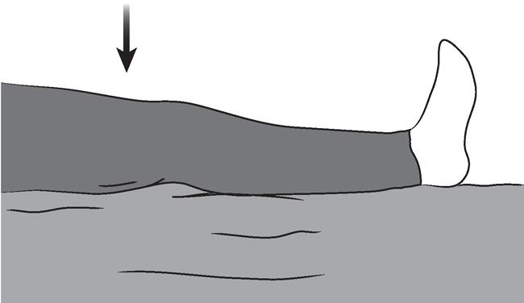

Straight Leg Raises
Tighten your thigh muscle with your knee fully straightened on the bed. Lift your leg several inches. Hold for 5 to 10 seconds. Slowly lower.
Repeat for 10-15 reps
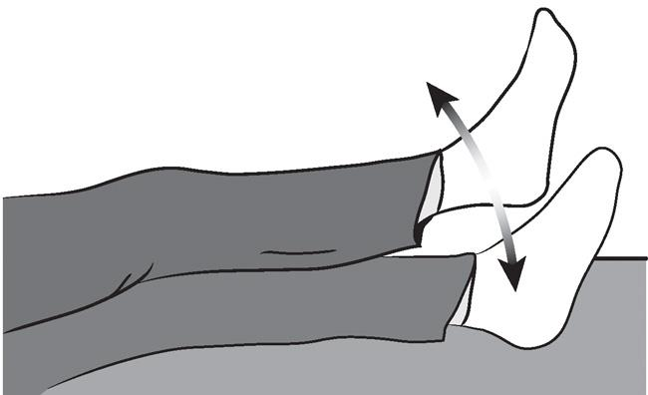

Standing Exercises
Lift your operated leg toward your chest. Do not lift your knee higher than your waist. Hold for 2 or 3 seconds and put your leg down.
Repeat 10–15 times. Repeat for 3 or 4 sessions a day
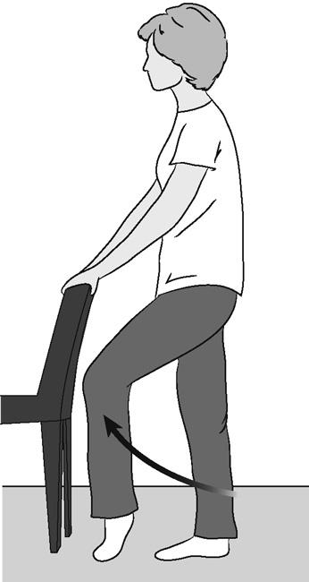
LHSH Joint Replacement Program Navigator #  806-300-1375  Mon-Fri 8:00 to 4:00  Call your surgeon outside of these times | Call Your Surgeon | Call Navigator | You Are Doing Great
Pain | - My pain is so bad that I cannot do much  - I have pain that is sharp or stabbing  - Medication, ice, or rest do not help my pain  - My pain keeps me from sleeping at night | - I am moving around ok but have to stop due to pain  - My pain is getting worse  - My pain medicine is not helping like it was before  - I have difficulty falling and staying asleep | - Every day I am getting better  - I can perform my exercises and I feel good after taking pain medication or using ice  - I am able to sleep at night
Surgical Dressing/Site | - The skin around my surgical site is bright red and swollen  And/Or  - The skin is hot to the touch around my surgical site  - I have a fever of 101.5 or higher  - I see green or yellow discharge coming from my surgical site | - I see clear drainage  - My temperature is >99.5 and <101.5  - My surgical site feels and looks different than when I left the hospital | - My surgical site and dressing are clean and dry  - My temperature is normal  - My skin is not warm or swollen and looks normal around the surgical site
Bowel Movements (Pooping) | - I have not pooped since I left the hospital or within the past 3 days  - The stool softeners are not working  - My belly looks bigger  - I often feel like I am going to throw up  - I am not able to eat | - I have hard, small poop in the last 1-2 days  - The stool softeners do not seem to help  - I eat ½ or less of my meals  - I feel bloated | - I have had normal bowel movements since I left the hospital  - My appetite is good
Exercise/Activity | - I am not able to do my exercises  - I spend most of the day resting  - I feel confused, dizzy, or weak  - I am worried about my movement and don’t know what to do | - I have lost my balance and need to hold onto things to walk  - I don’t feel I am where I should be in my recovery  - I am doing my exercise, but progressing slowly | - I have not had any concerns  - I am able to perform all of my exercises  - I feel like I am progressing as I should be

HOW TO MAKE YOUR HOME SAFE AND COMMON WAYS TO PREVENT FALLS
- Keep emergency phone numbers, including phone numbers of friends and family posted on or near telephone.

- If you live alone, stay in contact with relatives or neighbors on a daily basis.

- Use a pill organizer to keep track of daily medication and call your physician if you have any questions about your medication.

- Keep extension cords and telephone cords out of pathways. Use cordless phone or cell phone.

- Remove all throw rugs.

- Clear clutter from the floor and pathways.

- Watch for small pets, which tend to get under foot.

- Avoid changing positions quickly, when getting up and down stand for a moment until you are no longer dizzy; if you become dizzy sit down.

- Avoid chairs without arms, and other low surfaces.

- Rearrange furniture to open paths through rooms and eliminate tripping hazards.

- Place frequently used items in reach.

- A light and telephone should be placed next to your bed to increase your safety at night.

